No. | Answer
 | The International Space Station gets energy from the Sun when it can, but sometimes it is in darkness, so cells are needed to store energy that can be used during the ‘dark’ times.
a +3
b +2
a Ni(OH)₂
b H₂O
 | 2NiOOH(s) + H₂(g) → 2Ni(OH)₂(s)
30% m/m means 30 g of KOH in 100 g of solution
∴ 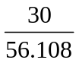 mol of KOH in 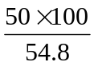 mL of solution
[KOH] = 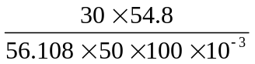 = 5.9 mol L^{–1}
 | It does not change. Although OH– is consumed at the anode, it is produced at the cathode.
a It increases (H₂ produced).
b It decreases (H₂ consumed).
 | It must be unreactive in a highly alkaline solution, allow good ion flow, and be structurally stable so that good separation is maintained.
 | The oxidant and reductant could react directly and no electrons would flow through the external circuit.
For example:
Advantage: long life
Disadvantage: expensive

